**Experiment No :** 1

**Experiment name :** Write a C Program to add two matrices.

**Methodology :**

1. Take the input for the size and elements of both matrices from the user.
2. Check if the dimensions of both matrices are compatible for addition (i.e., they have the same number of rows and columns).
3. Perform the addition operation and store the result in another matrix.
4. Display the resulting matrix after addintion.

**Flow-Chart :**

Enter elements of second matix :

Print: sum

For(i=0;i<row;i++){for(j=0;j<col;j++)}

Output : total sum of matrix

Scanf(“%d”,second[i][j]

For(i=0;i<row;i++){

for(j=0;j<col;j++)}

Sum[i][j]=first[i][j]+second[i][j] ;

Declear ->I , j , row , col , first[10],second [10]1[10], sum[10][10]

Input number of columns and rows

Enter elements of first matix :

For(i=0;i<row;i++){

for(j=0;j<col;j++)}

Scanf(“%d”,first[i][j];

**Code :**

#include<stdio.h>

int main()

{

int i,j, row , col, first[10][10],second[10][10], sum[10][10] ;

printf("Enter the number of rows & columns(between 1 and 100) : ");

scanf("%d %d",&row ,&col);

printf("Enter elements of first matrix :\n ");

for(i=0 ; i<row ; i++){

for(j=0 ; j<col ; j++){

scanf("%d",&first[i][j]);

}

}

printf("Enter elements of second matrix : \n");

for(i=0 ; i<row ; i++){

for(j=0 ; j<col ; j++){

scanf("%d",&second[i][j]);

}

}

printf("Sum of Entered Matrix:-\n");

for(i=0; i<row ; i++){

for(j=0 ; j<col; j++)

{

sum[i][j] = first[i][j] + second[i][j] ;

printf("%d\t",sum[i][j]);

}

printf("\n");

}

return 0;

}

**Output:**

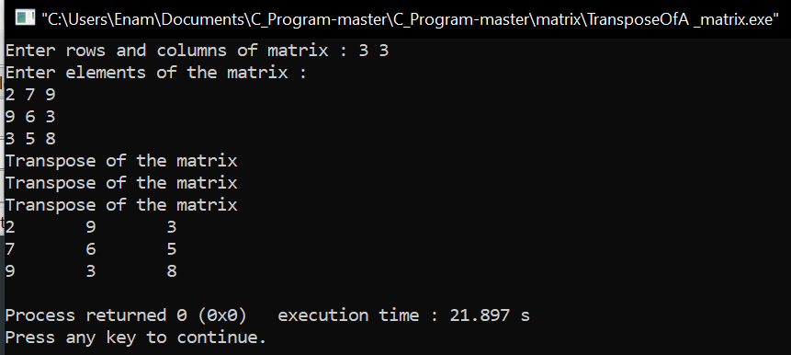

**Result discussion :**

In this matrix we take the column and row of the best matrix from the user, then the elements of the first matrix are taken from the user, then the elements of the second matrix are again taken from the user, this time the two matrices are added and the output is shown to the user.